User Acceptance Testing (UAT) Template
Date | 23 March 2025
Team ID | SWTID1743498710
Project Name | I-Movies: Movie Ticket Booking System
Maximum Marks

Project Overview:
Project Name: I-Movies: Movie Ticket Booking System
Project Description: A full-stack web application that allows users to browse, search, and book movie tickets across multiple cities, view movie details, select seats, and receive digital booking confirmations.
Project Version: v1.0.0
Testing Period: [Start Date] to [End Date]
Testing Scope:
Features to Test:
- User registration/login
- Movie search and listing
- Seat selection and ticket booking
- Payment gateway mock integration
- Confirmation via email
User Stories to Test:
- As a user, I can register and log in
- As a user, I can search and view movies
- As a user, I can book tickets and receive confirmation

Testing Environment:
URL/Location: [Web URL or Application Location]
Credentials (if required): [Username/Password]
Test Cases:
Test Case ID | Test Scenario | Test Steps | Expected Result | Actual Result | Pass/Fail
TC-001 | User Registration | 1. Navigate to Sign-Up Page  2. Enter valid email, password  3. Submit form | User is registered and redirected to dashboard | Works as expected | Pass
TC-002 | Movie Search Function | 1. Enter movie name  2. Click search | Relevant movie results shown | Search is functional and accurate | Pass
TC-003 | Booking a Movie Ticket | 1. Select a movie  2. Choose a city, theater, and time  3. Pick seats  4. Confirm and Book | Booking confirmation shown | Ticket booked, confirmation email received | Pass
TC-004 | Invalid Input in Registration | 1. Enter invalid email or weak password  2. Submit | Appropriate error message displayed | Validation messages appear correctly | Pass
TC-005 | Payment Flow (Mock Test) | 1. Choose payment method (mocked)  2. Click pay | Booking completed with mock payment success | Redirected to success page | Pass

Bug Tracking:
Bug ID | Bug Description | Steps to reproduce | Severity | Status | Additional feedback
BG-001 | Minor UI misalignment in login box | 1. Open login  2. Resize screen to 768px  3. Check alignment | Low | Closed | Fixed with responsive CSS
BG-002 | Confirmation email delay | 1. Book ticket  2. Wait for confirmation | Medium | In Progress | Delay of 20–30 sec observed

Sign-off:
Tester Name: Jaydev Mod
Date: 23 March 2025
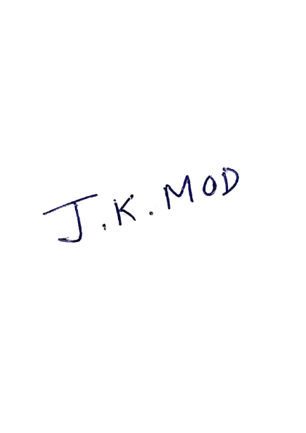
Signature:

